**Political Juggernauts: A Quantitative Analysis of Candidates in the 2019 Lok Sabha Elections**

If a person wants to become a member of the Lok Sabha, he must be a citizen.

One must be 18 years of age to vote

The candidate's name must be included in the electoral roll of any part of India

The candidate's name must be included in the electoral roll of any part of India

Candidates should not hold any salaried post in State Government or Central Government posts

Contenders should not be mentally ill and unable to repay the loan received

Candidates should not have been convicted for violating election rules in a previous election

Candidates should not have a conviction of more than 2 years

2019 Lok Sabha Elections 2018 crime cases and number of votes 594, 240, 703. They won a total of 539 constituencies

Education is not a big factor in elections 2019 Loksabha election 5th class girl got around 118400 votes. So money is important in elections

2019 Lok Sabha Election Winner B.J. Team P is the state that has won the most seats. That is 78 volumes

The sheet defines state wise general and postal votes. For example 2019 Lok Sabha elections in Tamil Nadu

The total number of votes cast is 4,08,18,5 out of which 2,01,92 postal votes have been cast.

The sheet explained tha lok shaba state wise criminal cases.Criminal cases are usually registered during elections. For example, in 2019, 251 criminal cases were registered in the state of Uttar Pradesh

The BJP won 300 of the total 539 seats in the Lok Sabha elections. In other constituencies, Congress and other parties won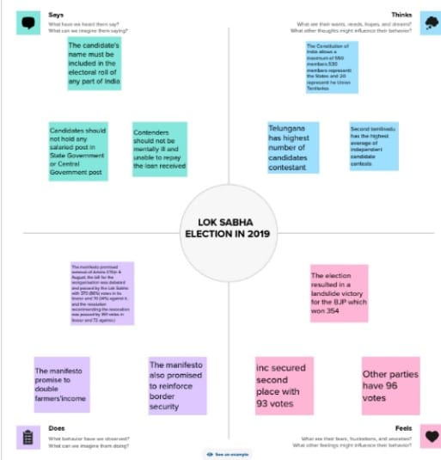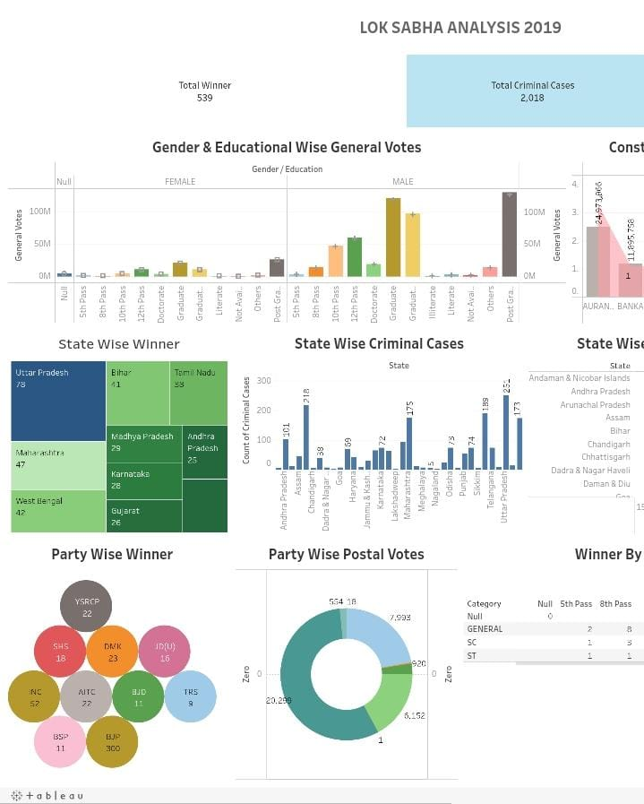

**RESULT:**

2019 Lok Sabha Elections 2018 crime cases and number of votes 594, 240, 703. They won a total of 539 constituencies

Education is not a big factor in elections 2019 Loksabha election 5th class girl got around 118400 votes. So money is important in elections

2019 Lok Sabha Election Winner B.J. Team P is the state that has won the most seats. That is 78 volumes

The sheet defines state wise general and postal votes. For example 2019 Lok Sabha elections in Tamil Nadu

The total number of votes cast is 4,08,18,5 out of which 2,01,92 postal votes have been cast.

The sheet explained tha lok shaba state wise criminal cases.Criminal cases are usually registered during elections. For example, in 2019, 251 criminal cases were registered in the state of Uttar Pradesh

The BJP won 300 of the total 539 seats in the Lok Sabha elections. In other constituencies, Congress and other parties won